CHAPTER 3

SYSTEM DESIGN

System design is the process or art of defining the architecture, components, modules, interfaces, and data for a system to satisfy specified requirements. One could see it as the application of systems theory to product development. There is some overlap with the disciplines of systems analysis, systems architecture and systems engineering

3.1 Architecture

The over all architecture of DevOps model is contains all the following operation



Q12q1 Fig 1.1:DevOps Architecture

3.2 Level-0 DFD:

Over all structure of project

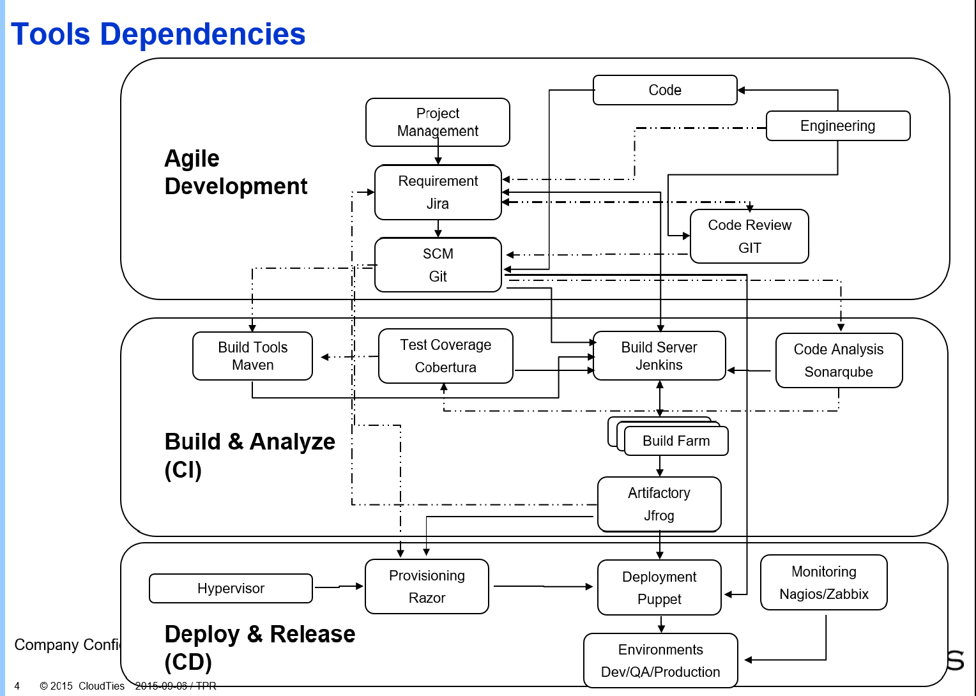

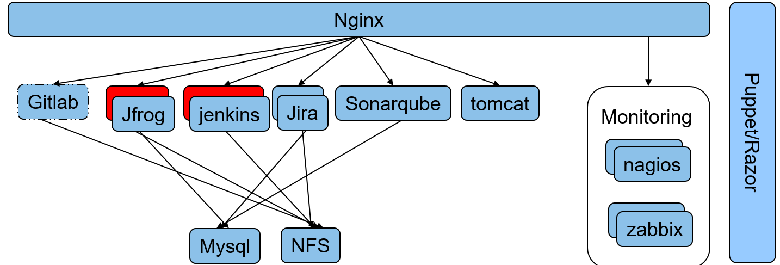



3.3 Level- 1 DFD:

3.3.1 Maven

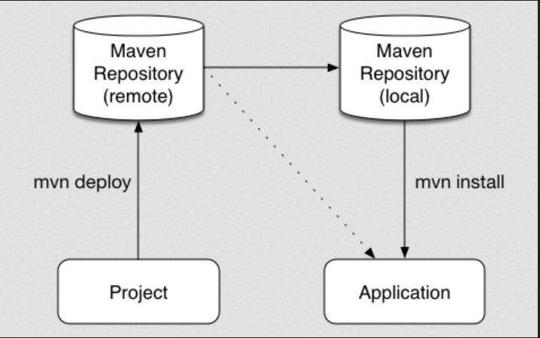

3.3.2 Git

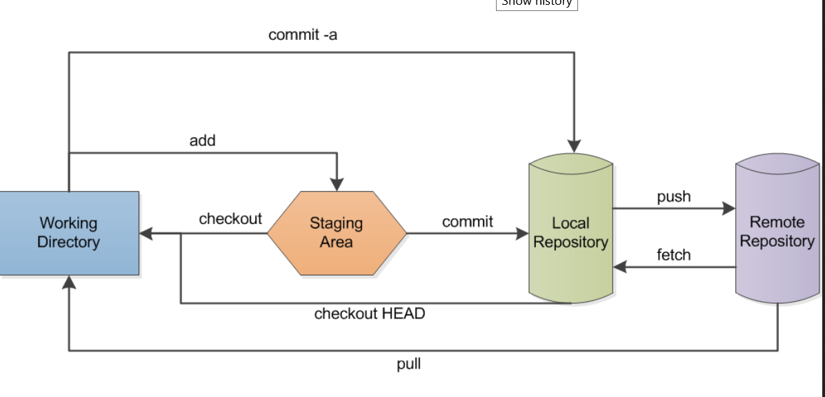

3.3.3 Puppet

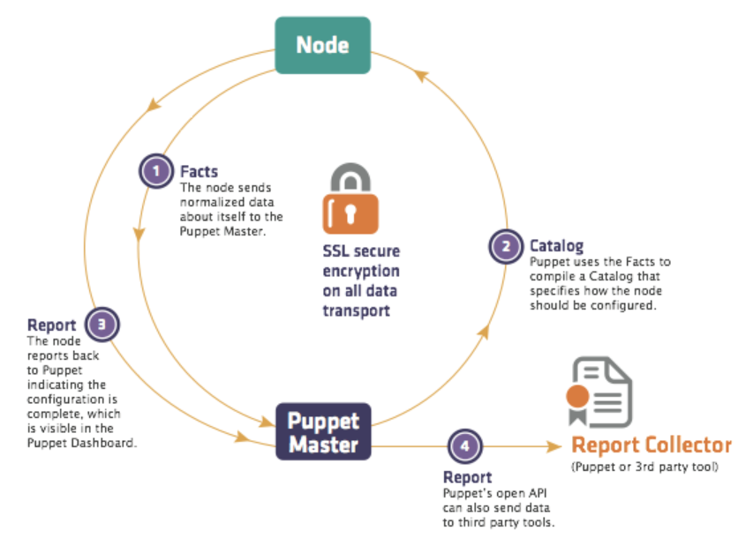

3.4 Use Case